Kubernetes Demo

First create project by clicking on NEW PROJECT- label

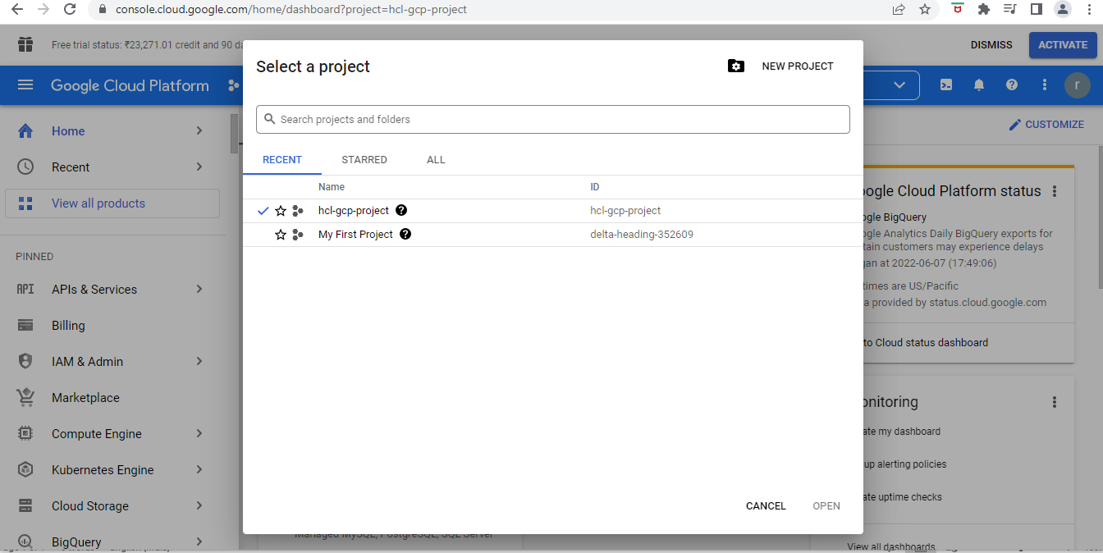

Activate the “Cloud shell” on highlighted button and click continue

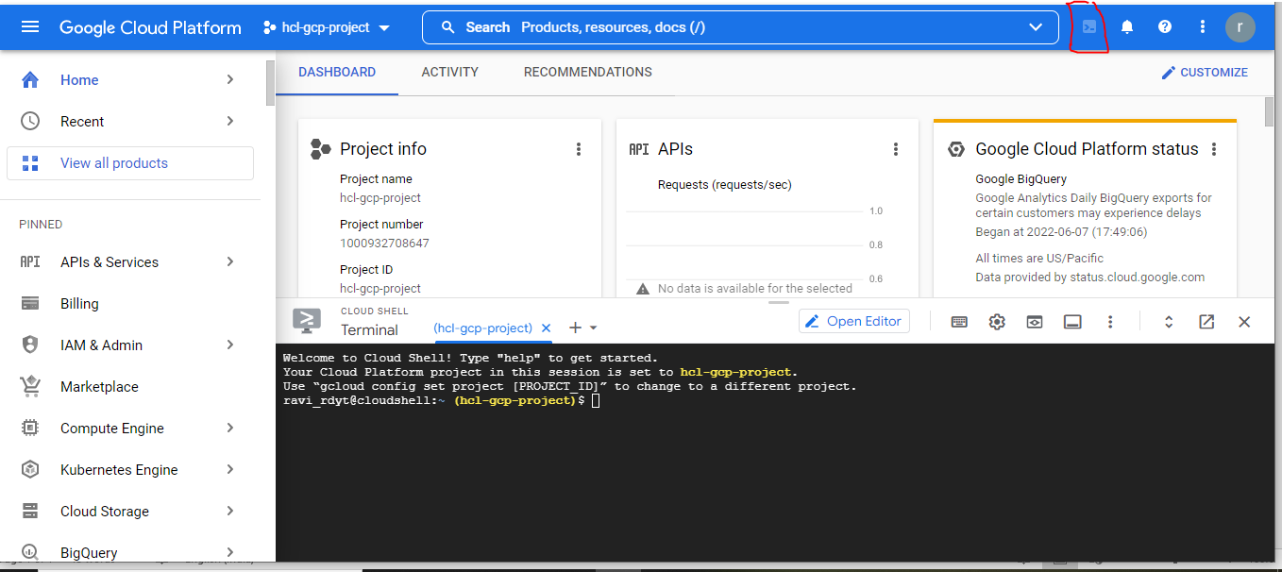

Clone the sample project from Github

CMD : git clone https://github.com/GoogleCloudPlatform/kubernetes-engine-samples

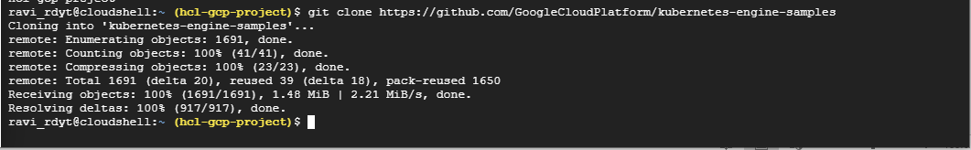

CMD : cd kubernetes-engine-samples/hello-app

Set project id at Environment variables

CMD : **export PROJECT_ID = [YOUR PROJECT ID]**

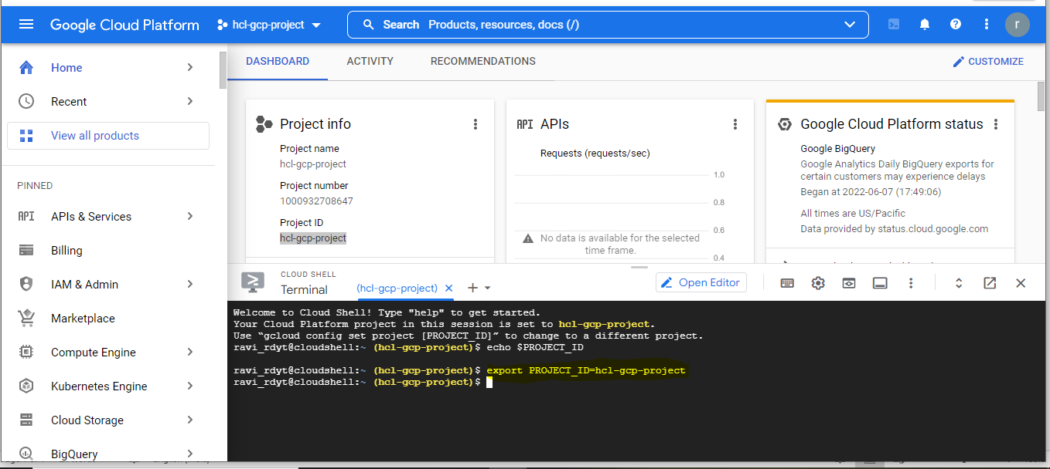

Its time build “**Docker Image**” for the hello-app

CMD : **docker build -t gcr.io/${PROJECT_ID}/hello-app:v1 .**

Gre – refers to Container registry

Continue by clicking on “authorization” button

Out/put : You can see that docker image is beeing created

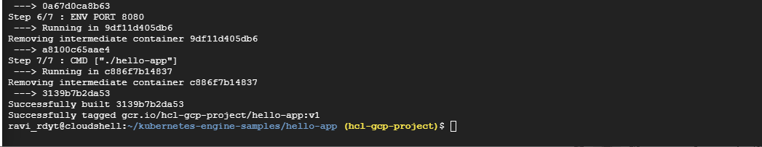

Verify “Docker imge build”

CMD : **docker images**

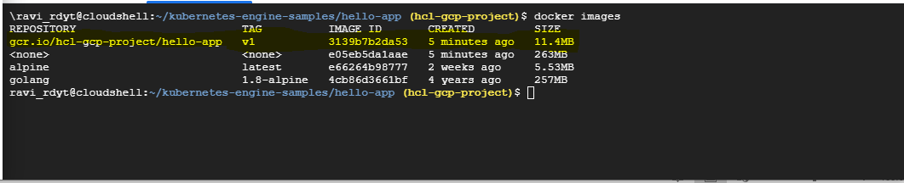

After that, we have to push the image into “Container registry”, so that GKE cluster can download the image from the container registry and run the image in the GKE cluster.

For this we have to enable and authenticate to the “container registry”

Enable

CMD : **gcloud services enable containerregistry.googleapis.com**

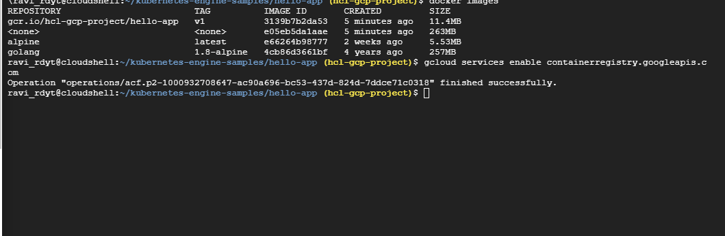

authenticate

CMD : **gcloud auth configure-docker**

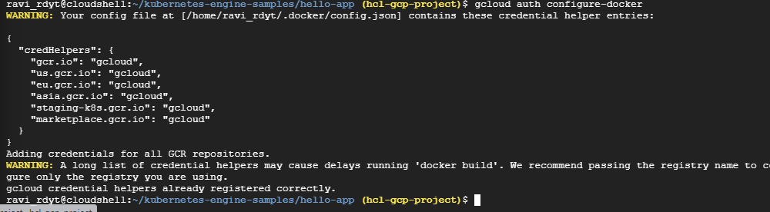

Then Push the image to the container registry”

CMD : docker push gcr.io/${PROJECT_ID}/hello-app:v1

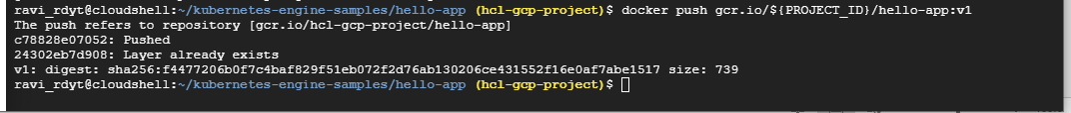

Note : Now you see the docker image is pushed to the “Container registry”.

Next is to create “kuburnaties engine cluster”

Go to Kubernetes Engine from the right panel of GCP Console

Click on clusters and enable “Kubernetes engine API”

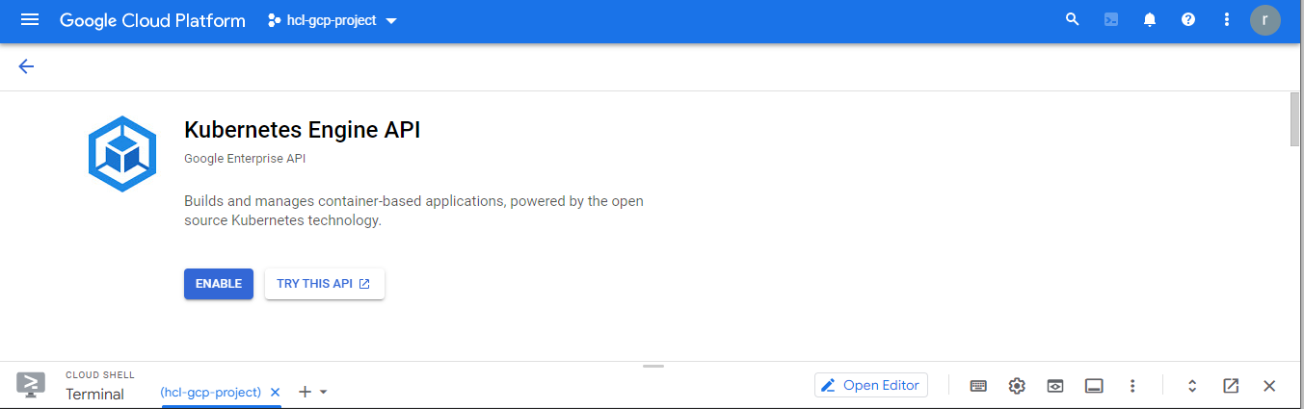

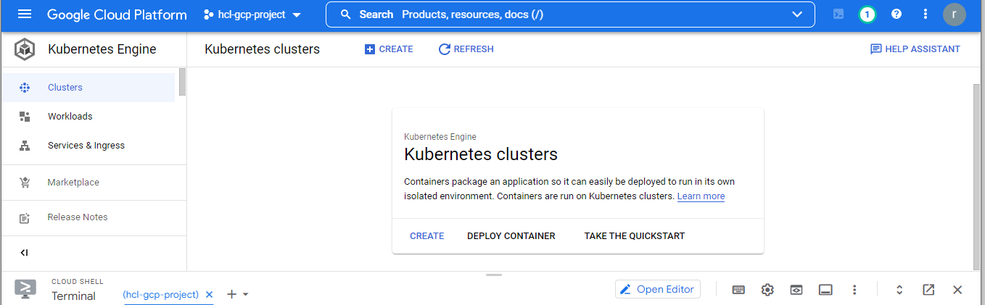

Click “Create”

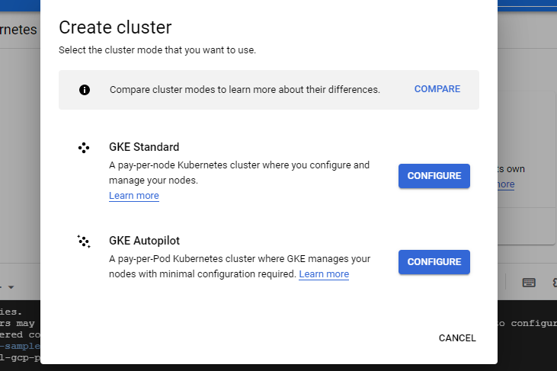

Select “GKE Standard” to configure.

Note : Overview the cost of the cluster

Name the cluster and left the zone by default and select static version

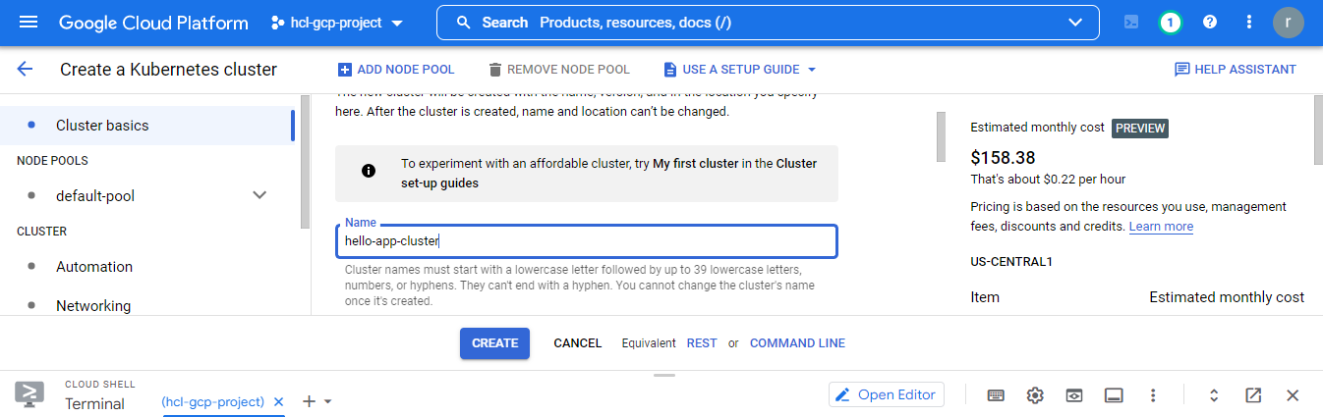

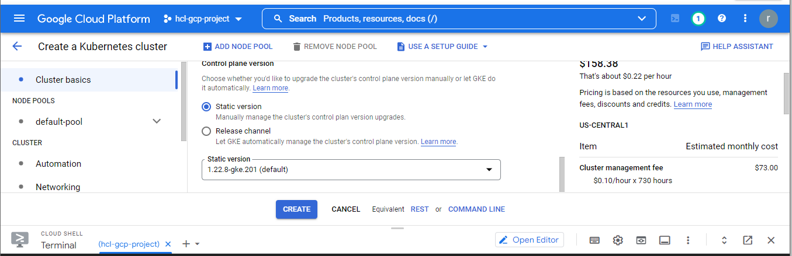

Click on “create”

Creating a cluster may take a couple of minutes  
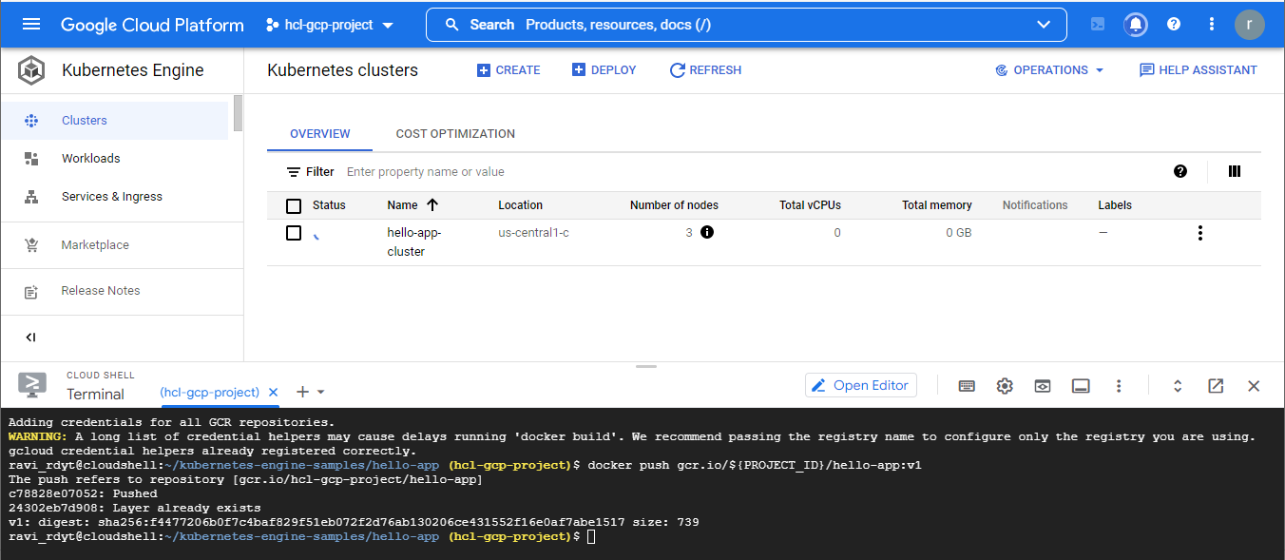

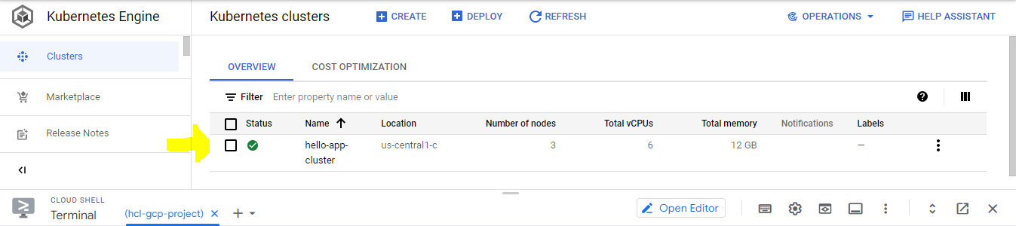

Next step is to Deploying sample application to GKE Engine, for this we have to create kubernetes deployment to run the application on the cluster and create horizontal Pod auto-scaler which scales the the number of pods it can be anywhere from one to five based on CPU load for that we have to go to “Workloads” from GCP Console

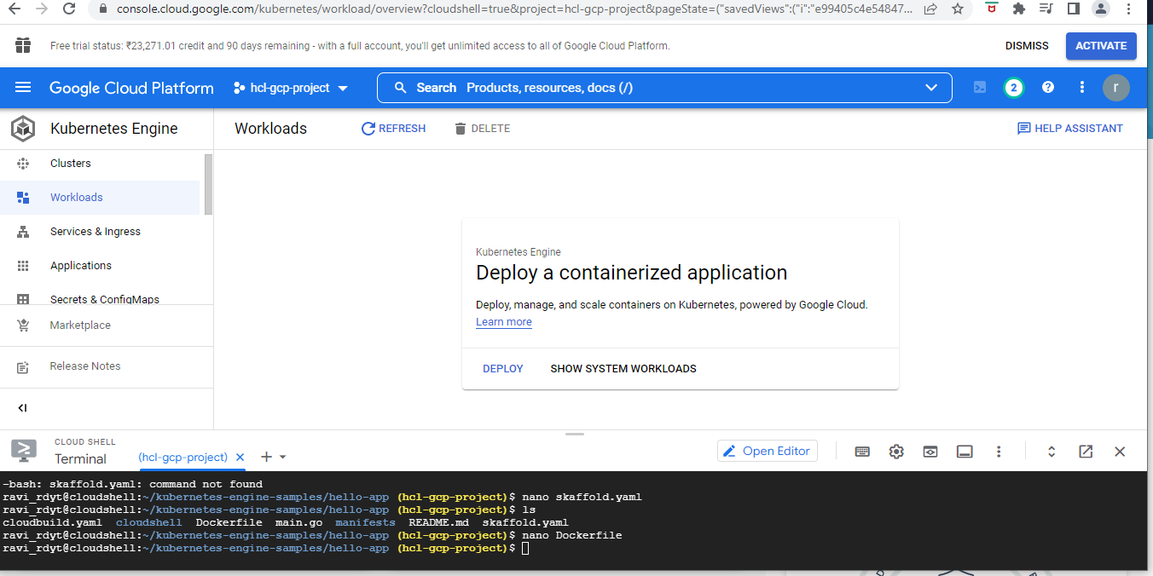

Click on “Deploy”, we have existing container image in the registry” just select

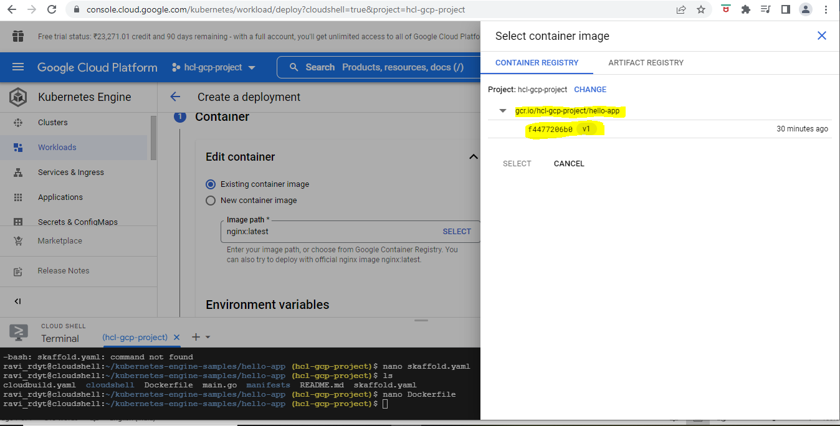

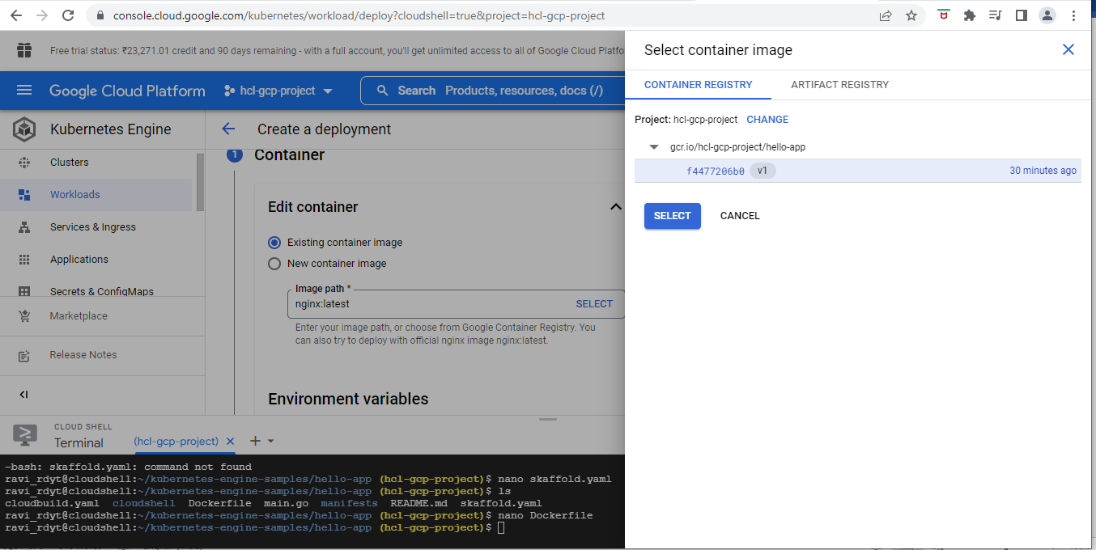

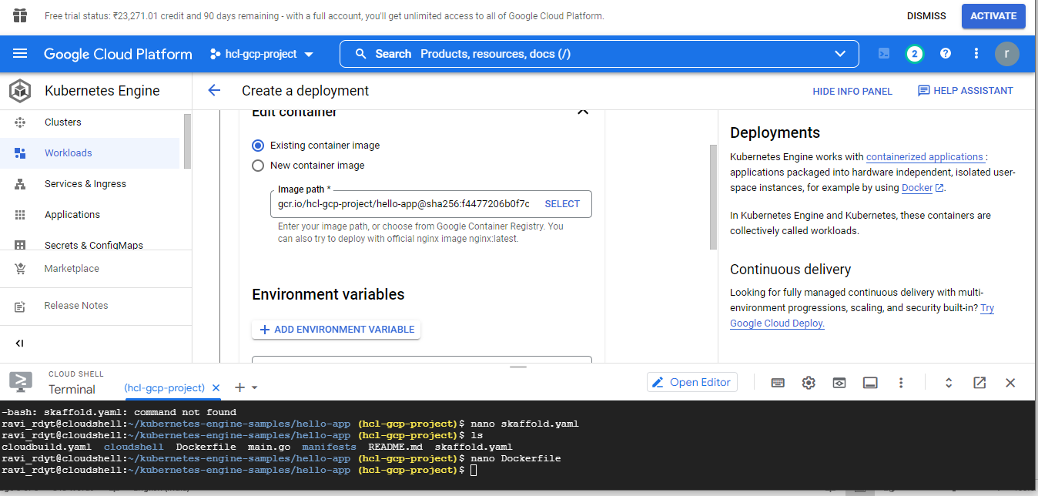

Click Done” and Continue

Next is to configure.

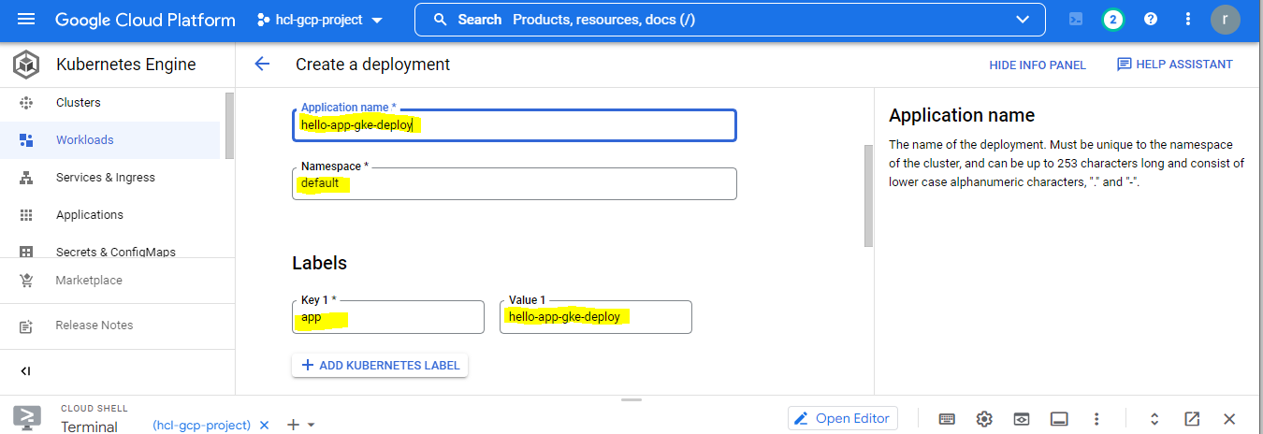

Provide the above fields as you like

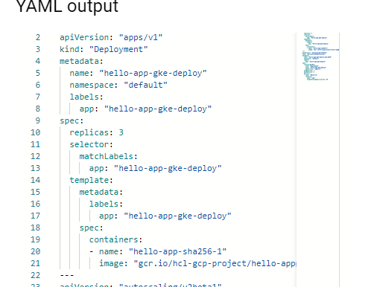

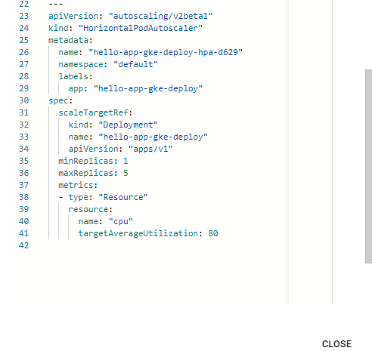

Here you see two deployments happening

1)Deployment

2)HorizontalPodAutoscaler

Click on “Create” and “ deploy”.

It will take couple of minutes to deploy

Once it created examine the overview, details…

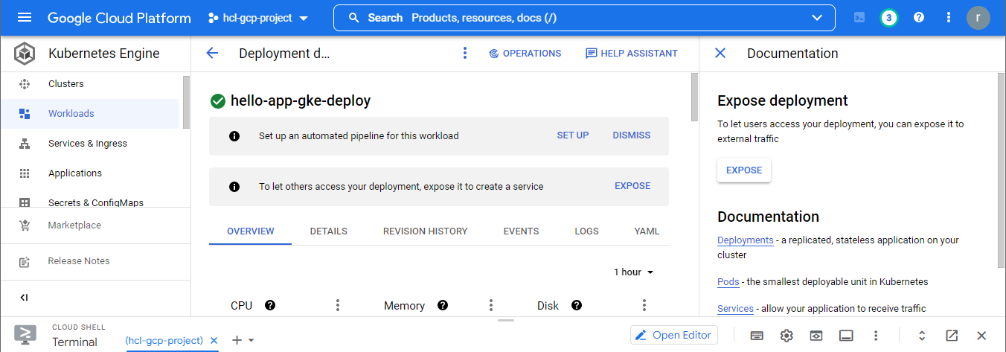

After creation of deployment, we are going to expose the sample application to internet.

To do that, click on expose from right panel of deployment page from GCP Console.

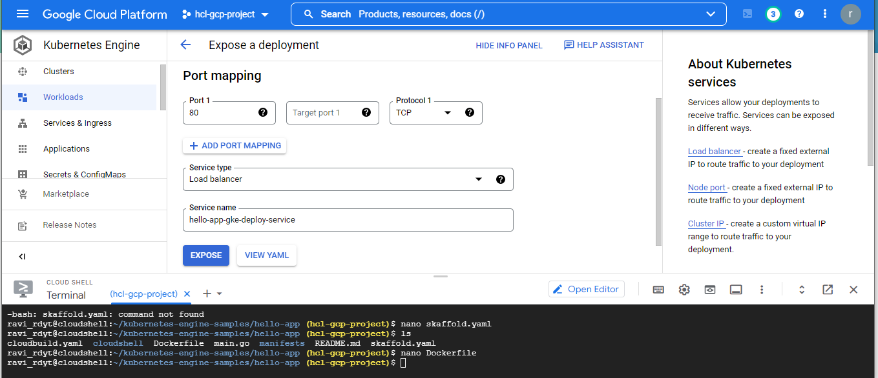

Give the port number “8080” as we define the application configuration settings

And leave the other fields to default

Click on “Expose” button

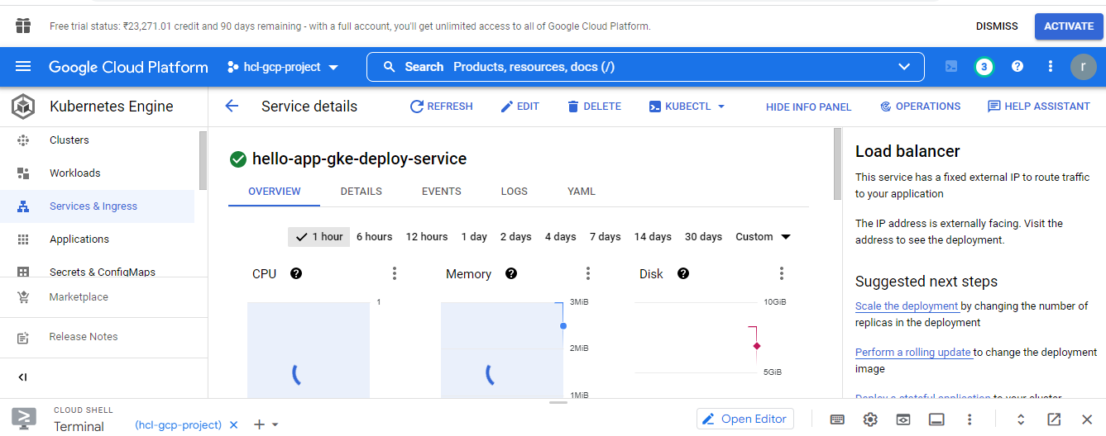

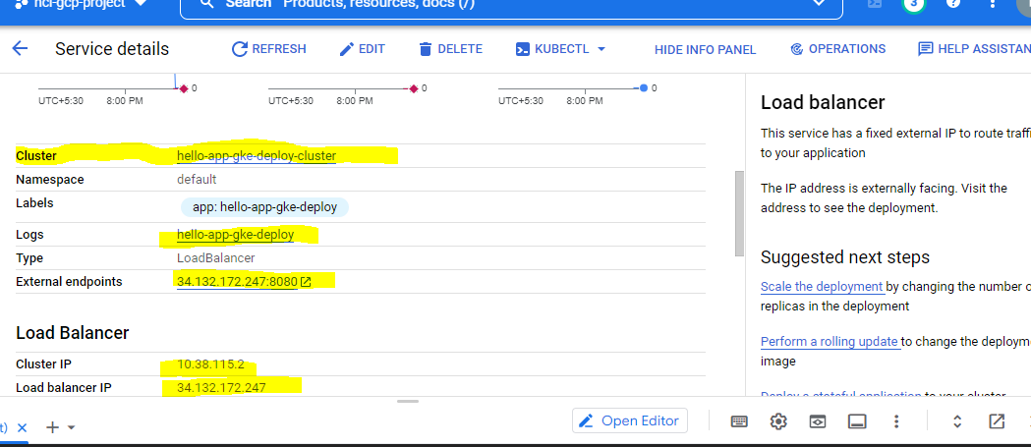

Click on “external IP Address” or copy the link and paste in the browser, you will see the response from the server as below

Web application

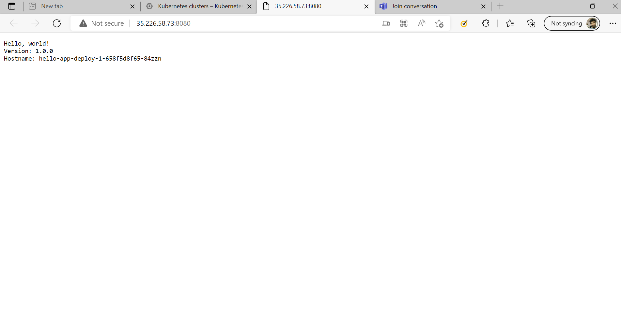

Now the application is distributed over internet

Note : once cluster created pls make sure to delete the cluster

